# System design:

## System Architect:

The system uses the MVC architectural pattern, which is divides the application into three interconnected layers these are Model, view, and controller.

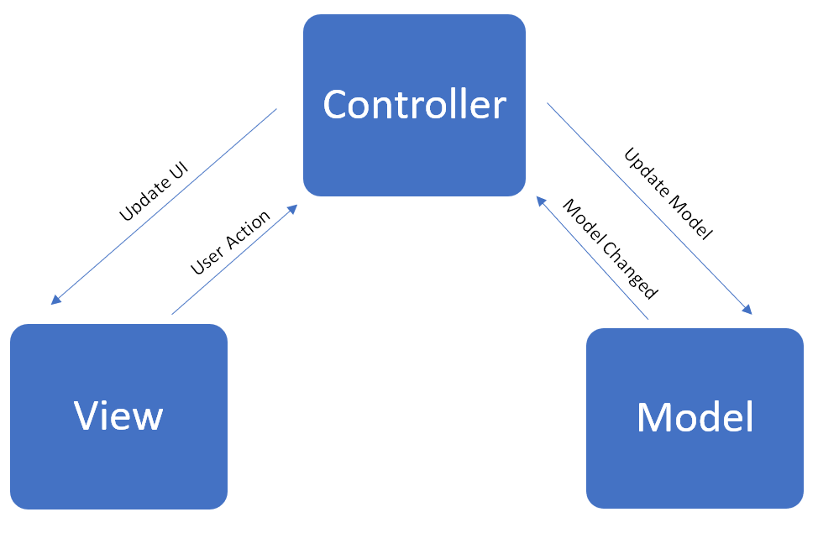

## GUI

The GUI is which technically classes fall in View layer, it has very vital role which is functioning as a mediator between user and other parts of the system, it is consists of menu bar and multiple buttons for the main widow, and for sub windows; the combo box and the table view they have been used significantly.

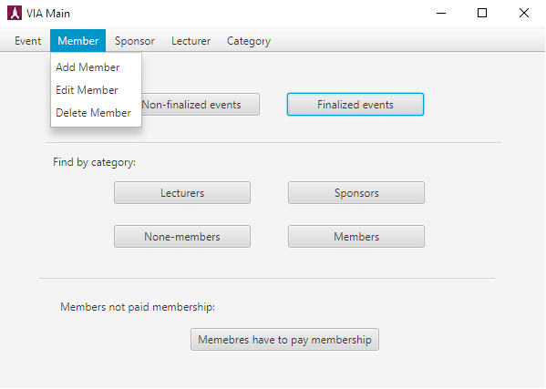

## Model Classes:

Model classes those are representing the blueprints of objects, the one class is a single entity which mean single object has its own fields and methods, the class below is a Lecturer class, so Lecturer object can be instantiated based on it.

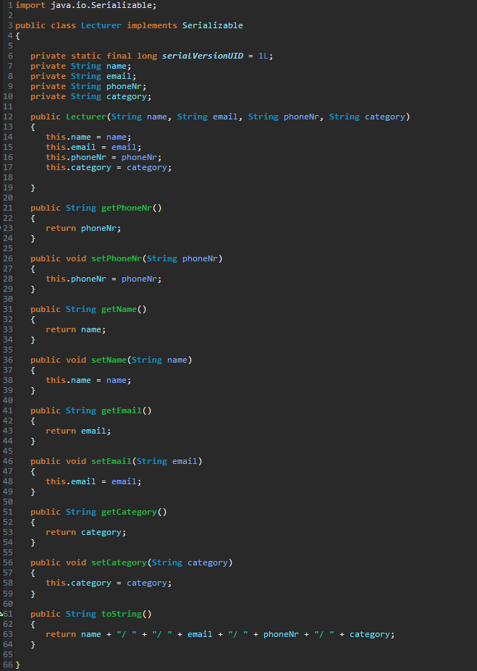

## Controller classes:

Controller classes are those classes interconnecting the model classes to view classes, so they play a mediator role between GUI and actual models, the class below is an AddLecturerController, it is using a lecturer class as a filed with one-to-many relationship, so array list has been used.

